***“FIRST PRIZE FOR THE PAPER PRESENTATION” AS “BEST PAPER*”** entitled “Woman and her Leadership Style in Education– A Study”in the UGC Sponsored National Conference on “Working Women: Problems and Prospects” at VHNSN College (Autonomous), Virudhunagar, Tamilnadu on 20th July, 2017.

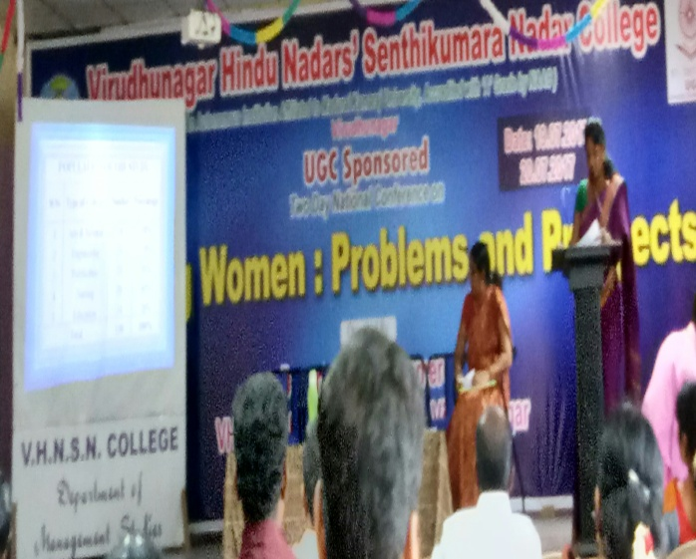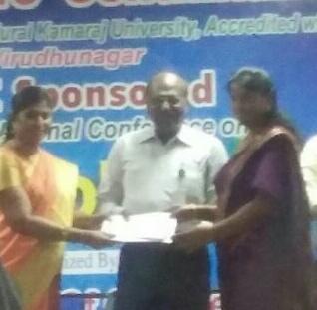

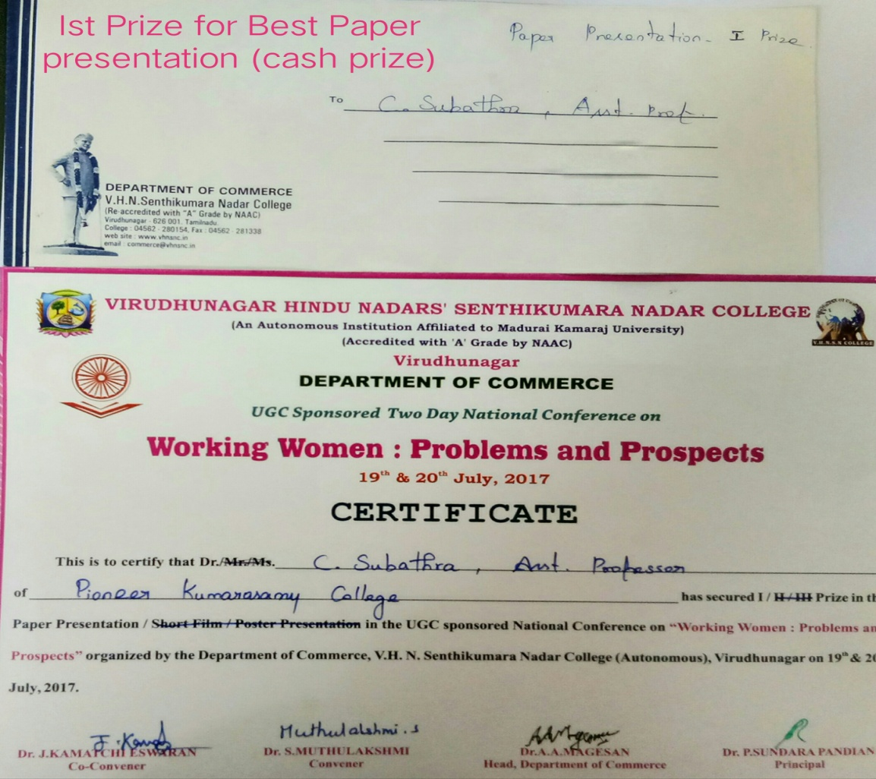

***“BEST PAPER AWARD”*** for the paper entitled “Behavioral Decision Style among the College Principals in Kanyakumari District, Tamilnadu” by International Journal of Research - Grandhalayah, 08.01. 2017.

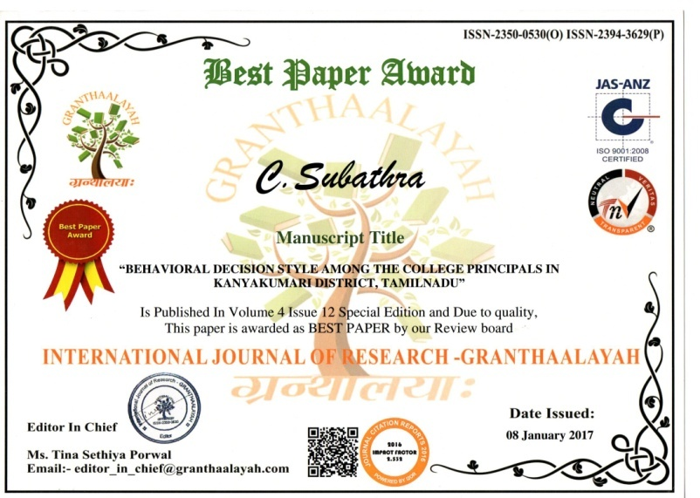

***“BEST PAPER AWARD”*** for the International Conference on “*Women Empowerment: Across the Continent”* on 22nd & 23rd July 2016.

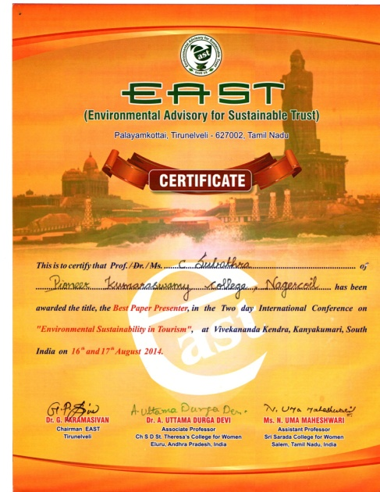

Certificate of Appreciation received for Conducting **“*BLOOD DONATION CAMP”*** from Tamilnadu State Blood Transfusion Council, Government of Tamilnadu on 02.05.2018.

